CGT / CNIT 141 Lab 1
Objectives:
- Create a very basic xHTML page using CSS
- Get familiar with course infrastructure
- Set up web publishing environment & domain name
- Get familiar with submission requirements for course
- Identify Good & Bad web sites

Description
The two main objectives for this lab are (a) creating a simple web-page that uses CSS, and (b) to get familiar with technological infrastructure for this course. You will do this by creating web page as shown in figure 1. The structural tag should be in xHTML and the formatting in CSS. You will then (a) deploy the web page to a web site, and (b) turn it into the G drive.

Implementation
1. Register for a free hosting account
You may use any hosting account. You will need to give you TA access to this account.

Possibilities:
- Brinkster - http://www.brinkster.com/hosting/FreeDeveloper.aspx
- 000webhost - http://www.000webhost.com/
- DotEasy - https://www.doteasy.com/SignUp4/index.cfm
- Lime Domains - http://www.limedomains.com/hosting

2. Create a Web Page that looks like the figure below

a) Overview

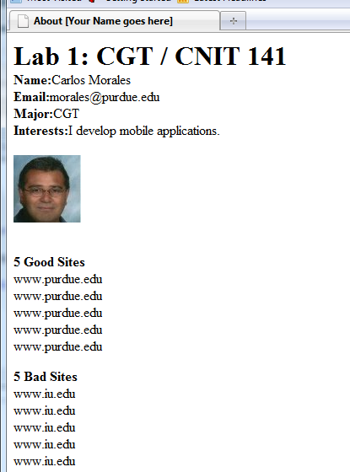 | The contents for the page should include:  a)your name  b)your email address  c)a jpg image of yourself  d)a table that lists at least 5 good and 5 bad (10 total) sites that you liked/disliked from  http://www.commarts.com/webpicks

b) Create a directory structure on your local computer as shown below

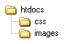

c) Inside of htdocs create a new text file (Right Click->New->Text Document). Give it the name index.html (if your file extensions are hidden, call your TA).

d) Open your index.html and type the lines below. Your TA will explain what each line means.

<!DOCTYPE html PUBLIC "-//W3C//DTD XHTML 1.0 Transitional//EN"
"http://www.w3.org/TR/xhtml1/DTD/xhtml1-transitional.dtd">
<html>
<head>
<meta http-equiv="Content-type" content="text/html; charset=UTF-8" />
<title>About [Your Name goes here] </title>
<meta http-equiv="Content-Language" content="en-us" />

<meta name="description" content="Description" />
<meta name="keywords" content="Keywords" />

<style type="text/css" media="all">@import "css/master.css";</style>
</head>

<body>

</body>
</html>
At this point, you have an empty XHTML with no content. The only thing that it is doing is trying to import a CSS file named master.css from the CSS directory.

Let's fill in the content

e) Between the <body> </body> tags, create a <div> with an id="page-container" attribute:
<body>

<div id="page-container">
</div>

</body>
f) Now put another div inside of the page container. Call this one "content"

<body>

<div id="page-container">
<div id="content">
</div>
</div>

</body>
g) Next, we will add some content side inside of your DIV tags

<div id="page-container">
<div id="content">
<h1>Lab 1: CGT / CNIT 141</h1>
<p><strong>Name:</strong>Carlos Morales</p>
<p><strong>Email:</strong>morales@purdue.edu</p>
<p><strong>Major:</strong>CGT</p>
<p><strong>Interests:</strong>I develop mobile apps</p>
<br />
<img src="images/morales.jpg" alt="carlos" /></div>
<br />
<p>
<strong>5 Good Sites</strong><br />
www.purdue.edu <br />
www.purdue.edu <br />
www.purdue.edu <br />
www.purdue.edu <br />
www.purdue.edu <br />
</p>
<p>
<strong>5 Bad Sites</strong><br />
www.iu.edu <br />
www.iu.edu <br />
www.iu.edu <br />
www.iu.edu <br />
www.iu.edu <br />
</p>
</div>
</div>

<body>

h) At this point you have an xHTML document. We will now create its accompanying CSS file. Create the file master.css and put it inside of the css directory. Open the master.css file with a text editor and type.

#page-container {
width: 760px;
}

#content {
margin-right: 20;
background: white;
}

#content h2 {
margin: 0;
padding: 0;
}

#content p {
margin: 0;
padding: 0;
}

h1,h2 {
margin: 0;
padding: 0;
}

i) After you are satisfied with the results
(a) take a screenshot of your browser window using the Print-Screen Key
(b) save theimage to the root of your htdocs folder with the name screenshot.jpg
(c) copy all of your files to your on-line hosting account that you created in step 1 of this lab
(d) create a text file on the root of your htdoc folder named host.txt and put the url into it
(e) zip your entire htdoc folder into a zip file named (Lastname_first.zip) and put it into the appropriate folder on the g drive

Points:
10 pt. creating account
10 pt. XHTML file
10 pt. CSS file
10 pt. Folder structure
10 pt. Uploading materials

50 pt. Total

