CGT 141/CPT 141 Lecture 3 Wk 2
The Browser, the Display and Web Design

Issues with Browsers
- HTML is constantly changing. As a developer you have to deal with:
  - Older browsers that may not support the newest tags.
  - Making sure your site is readable by all browsers (including non-visual browsers).
  - Browser-specific tags (like <div> and <layer> tags).
  - Inconsistent rendering between browsers or platforms.
  - Deprecated tags.
- Two biggest visual design issues are (both related to the display):
  - Resolution
    - Refers to the sharpness & clarity of an image
    - Often used to describe:
      - Monitors
      - Printers
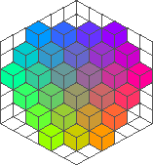
      - Raster graphics
Color Cube Slice
    - Indicates the number of dots per inch (dpi)
      - Also called pixels per inch (ppi)
  - Color Depth
    - Number of distinct colors that can be represented by a piece of hardware or software.
    - Often referred to as bit depth because color depth refers to the number of bits that can be used to describe a single pixel.
    - Describes the color fidelity of an image

- Biggest technical issue is:
  - Bandwidth
    - Bandwidth is the amount of data that can be transmitted in a fixed amount of time.
    - Usually represented in either
      - bits per second (bps) or
      - kilobits per second (kbps)
- Primary Browsers today:
  - Internet Explorer
  - Mozilla, Firebird, Camino
  - Netscape
  - Opera
  - Others (PDA, WebTV, etc.)
- Simple answer to incompatibilities:
  - Test, test, test.
  - Know thy audience (use programs like Analog or other analysis packages to see what users are using!!!)
- Design Strategies
  - Lowest common denominator
  - Current version design
  - Providing multiple versions
  - Various combinations of the two
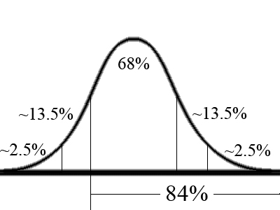
  - Suggested approach in this class:
    - 16%, 68%, 16% - the Normal Curve
    - Design for the upper 84% of the people

Dealing with Resolution
- Two Issues
  - Screen resolution setting
  - Area consumed by the browser’s chrome
- Screen resolution
  - Based on the capabilities of user’s video card
  - Is the physical pixel size of the graphical representation of the signal output from the video card
  - Is not associated with physical size of monitor hardware
  - Control Panels | Display
  - Common Settings:
    - 640x480 – typical of specialized audiences
    - 800x600 – most common for web design
    - 1024x768
    - 1280x1024
    - 1600x1024
    - 1600x1200
  - Biggest problem is to design a site that accommodates multiple (and alternative devices) with the least amount of rework.

Dealing with Color Differences
- There are some uncontrollable color differences:
  - Between platforms
    - PC colors on the Mac are usually slight desaturated and brighter
    - Mac colors on the PC are usually saturated and darker
  - Between monitors
    - Manufacturing differences
    - Small percentage have calibrated monitors
  - Color settings in the OS (based on capabilities of user’s video card)
    - 32-bit
    - 24-bit
    - 16-bit – colors shift and dither if JPG or PNG; shifting noticeable.
      - For example, white looks off-white
    - 8-bit – colors shift and dither if JPG or PNG; both shifting and dithering noticeable. – 256 colors
    - Even 4-bit – colors limited to 16!
- Must deal with color in two ways:
  - As it relates to graphic or bitmap images included in a page; color is defined within the image through the use of an image editor like PhotoShop. Additionally, the level of color needed by the image (designed around the audience and the graphic’s purpose) determines the file format used.
    - Will begin examining this in the next lecture when dealing with raster graphics.
  - As elements that are directly rendered on the fly by the browser.
    - Such as text, horizontal lines, links, tables, form elements, etc.
    - Color for these components is defined in the HTML code using color names or hexadecimal color codes.
    - We will not use color names because they are inaccurate.

Hexadecimal color
- Typically when working with color in graphics programs, you deal with color as either based upon color components or color attributes.
  - Color components: Red, Green, Blue / RGB / 255, 151, 31
  - Color attributes: Hue, Saturation, Brightness / HSB / 32?, 88%, 100%
- For the web, you must take the RGB values and convert the decimal representation to a Base16 (hexadecimal representation).
  - Computer typical deals with unfamiliar number forms, such as binary (Base2), Octal (Base8) and Hexadecimal (Base16).
  - Example: <body bgcolor=”#ffffff”>
- Hexadecimal number counts from 0 to 9 and then from A to F
- If you were to count to 29 in hexadecimal it would look like:

Dec | Hex |  | Dec | Hex |  | Dec | Hex
0 | 00 |  | 10 | 0A |  | 20 | 14
1 | 01 |  | 11 | 0B |  | 21 | 15
2 | 02 |  | 12 | 0C |  | 22 | 16
3 | 03 |  | 13 | 0D |  | 23 | 17
4 | 04 |  | 14 | 0E |  | 24 | 18
5 | 05 |  | 15 | 0F |  | 25 | 19
6 | 06 |  | 16 | 10 |  | 26 | 1A
7 | 07 |  | 17 | 11 |  | 27 | 1B
8 | 08 |  | 18 | 12 |  | 28 | 1C
9 | 09 |  | 19 | 13 |  | 29 | 1D

How do you convert decimal number to hexadecimal?
- Create a conversion matrix:

Decimal | Hexadecimal
0 | 0
1 | 1
2 | 2
3 | 3
4 | 4
5 | 5
6 | 6
7 | 7
8 | 8
9 | 9
10 | A
11 | B
12 | C
13 | D
14 | E
15 | F

- Given the decimal number: 142
  - Using long-hand division, determine the dividend and remainder
    - 142 / 16 = 8 R14
  - Look up the dividend and remainder in the conversion matrix:
    - Dec of 8 = Hex of 8
    - Dec of 14 = Hex of E
  - Thus, the hexadecimal representation of 142 is 8E

How do you convert decimal RGB representation to hexadecimal?
- Take each color specification (R, G, and B) and convert each to hexadecimal
- Combine the results to create the specification:
  - Decimal RGB: 255, 151, 31
  - 255 = FF
  - 151 = 97
  - 31 = 1F
  - Hexadecimal: FF971F
- Note: when you get preceding zeros (such as 01) do not truncate the preceding zero!
  - Decimal RGB: 86, 56, 15
  - 86 = 56
  - 56 = 38
  - 15 = 0F
  - Hexadecimal: 56380F

How do you convert hexadecimal representation to decimal RGB representation?
- Divide the 6 digits into 3 sets of two (RRGGBB => RR, GG, BB)
- Each of those 2 digit numbers is a dividend with a remainder
  - Hexadecimal: 80B5C4
    - 80 = 8 R0
    - B5 = 11 R5
    - C4 = 12 R4
  - Multiply each by 16 and add the remainder
    - 8 x 16 + 0 = 128
    - 11 x 16 + 5 = 181
    - 12 x 16 + 4 = 196
  - Decimal RGB: 128, 181, 196

Short cuts to RGB to hexadecimal conversions:
- Applications such as PhotoShop, Flash, or web editors that show you RGB and hexadecimal simultaneously.
- Lookup tables in books or on the web.
- Windows Calculator (or a handheld calculator)
- Show how to convert with it.

Where will you use hexadecimal codes?
- bgcolor attribute of the <body> and <table> tag
- color attribute of the <font> tag
- In Cascading Stylesheet color specifications
- Almost everywhere else where you can specify a color in HTML, CSS or webcentric applications (also in other programming environments).

Web-safe colors
- Certain hexadecimal colors are considered web-safe.
  - Any web-safe color that is used on the web will appear true to its original hue, saturation, and brightness.
  - Colors that are not in the web-safe palette may not appear correctly on the web.
- Any multiple of 3 is a web-safe color in hexadecimal
  - For each 2-digit number in hex, if that 2-digit number is in the following, it is web-safe
    - 00
    - 33
    - 66
    - 99
    - CC
    - FF
  - Examples of web-safe colors
    - 003366
    - FF99CC
    - FFFFFF
    - 000000
    - 33CC00

- The Web-Safe or Browser-Safe Palette only contains 216 colors out of a possible 256. That is because the remaining 40 colors vary on Macs and PCs. By eliminating the 40 variable colors, this palette is optimized for cross-platform use.

- The only reason to use the browser-safe palette is if you have a concern that your Web design work will be viewed from a 256 color (8-bit) computer system.
Lynda Weinman’s Complete Browser-Safe Color Palette ( 216 colors ):

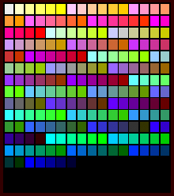

Windows 256 Color Palette:
- This is NOT the same as the image above. Some of these colors appear differently depending on the type of computer you are using.

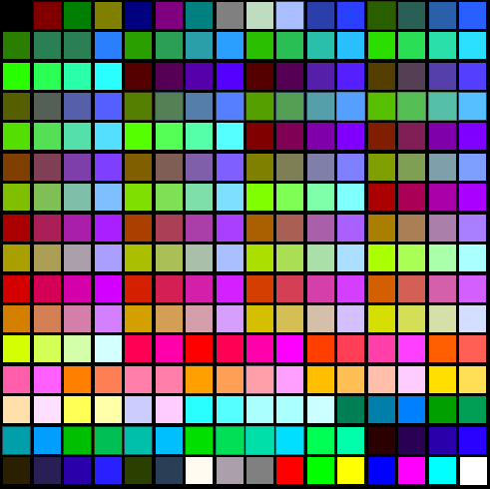
True Color Palette
- The image below is called "True Color" meaning that it simulates as closely as possible the same number of colors that would be viewed in the real world. Notice how each color smoothly goes into each other?

